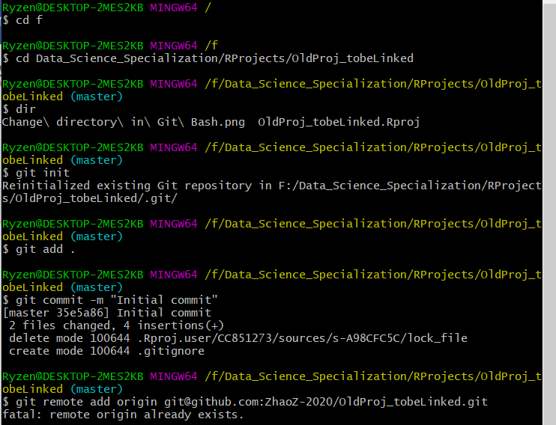

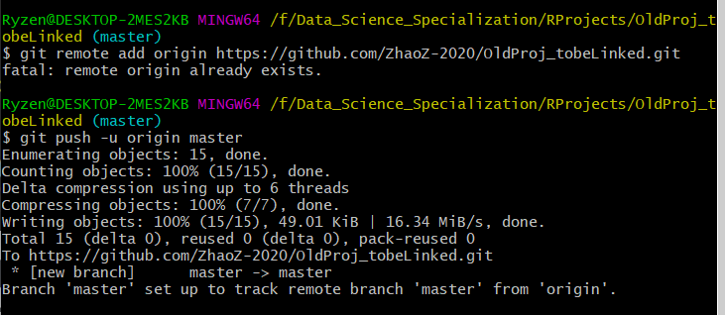

**…or push an existing repository from the command line**

git remote add origin https://github.com/ZhaoZ-2020/OldProj_tobeLinked.git

git push -u origin master